**Setting up Curses in Eclipse C++**

Right Click on the project-> Properties -> C/C++ Build-> Settings

Expand GCC C++ Compiler-> Include -> add the "Include" folder path

Eg:"D:\athul\Udemy\C++\Eclipse Workspace\include"

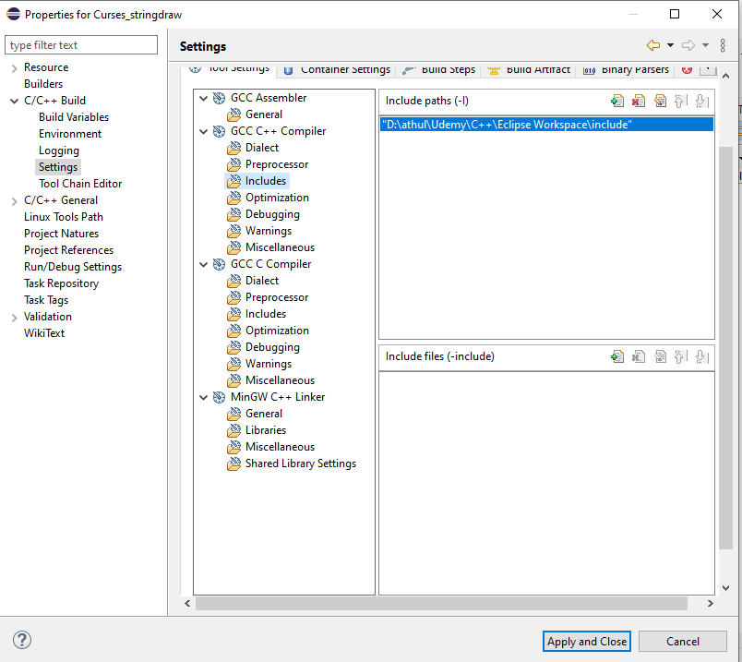

Expand MinGW C++ Linker -> Libraries

Add "pdcurses" in Libraries(-l) section and path of Lib Folder in "Library search path(-L)"

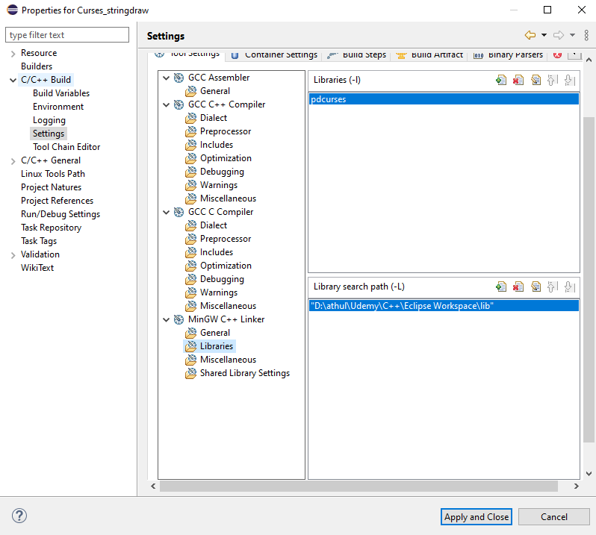

In MinGW C++ Linker -> Miscellaneous -> add following in "Linker flags" section:

-static-libgcc -static-libstdc++

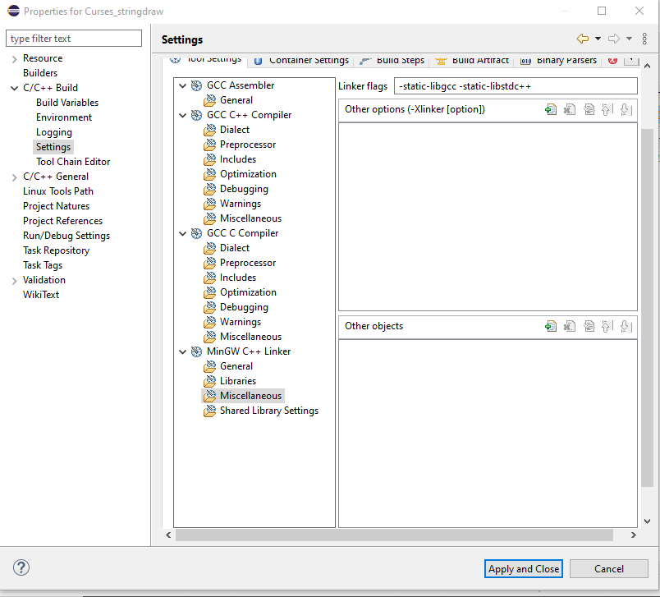

In Run -> External Tools -> External Tools Configurations add as following

Note: In below screen shot “Curses_stringdraw” is the project name. Replace it with your project.

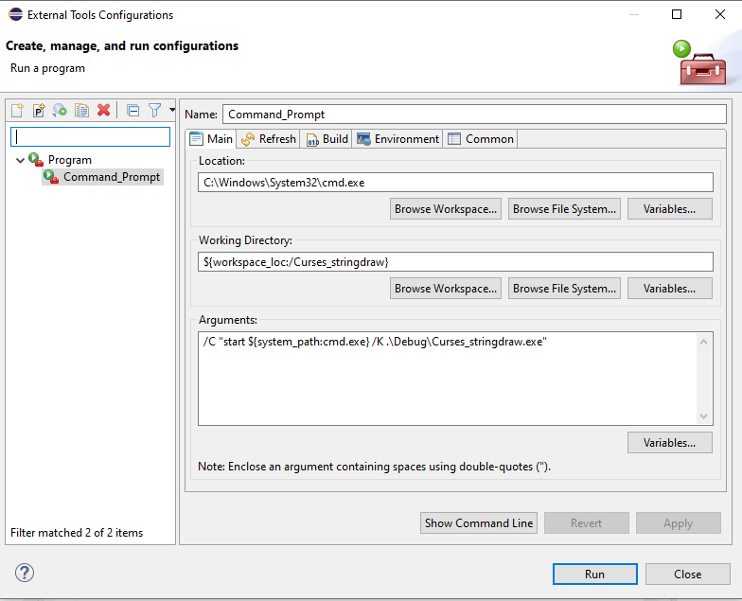

Add pdcurses.dll file to debug folder

